Controlled Vocabulary

🧾 What is Controlled Vocabulary
# Source: AI Source: Provided by: [Data Path: Persons Table -> ID Column: 1, Name_En Column: Motasem Essam] -> From: [Chatgpt (GPT-4-turbo)] on [7/30/2025]
Controlled vocabulary is a predefined, standardized list of terms used to ensure consistency and accuracy in labeling, classifying, or retrieving information—especially in information systems, libraries, databases, and technical fields.

✅ Key Features:
# Source: AI Source: Provided by: [Data Path: Persons Table -> ID Column: 1, Name_En Column: Motasem Essam] -> From: [Chatgpt (GPT-4-turbo)] on [7/30/2025]
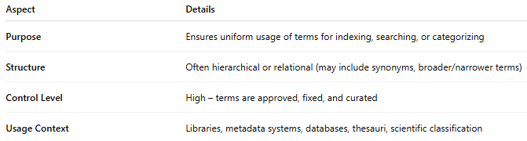
Aspect | Details
Purpose | Ensures uniform usage of terms for indexing, searching, or categorizing
Structure | Often hierarchical or relational (may include synonyms, broader/narrower terms)
Control Level | High – terms are approved, fixed, and curated
Usage Context | Libraries, metadata systems, databases, thesauri, scientific classification

🧠 Examples:
# Source: AI Source: Provided by: [Data Path: Persons Table -> ID Column: 1, Name_En Column: Motasem Essam] -> From: [Chatgpt (GPT-4-turbo)] on [7/30/2025]
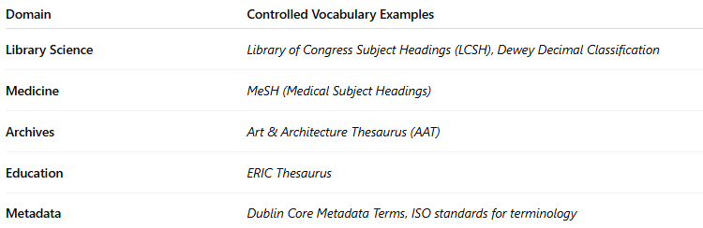
Domain | Controlled Vocabulary Examples
Library Science | Library of Congress Subject Headings (LCSH), Dewey Decimal Classification
Medicine | MeSH (Medical Subject Headings)
Archives | Art & Architecture Thesaurus (AAT)
Education | ERIC Thesaurus
Metadata | Dublin Core Metadata Terms, ISO standards for terminology
📌 Example: Instead of allowing both "car" and "automobile," a controlled vocabulary system might accept only "automobile" for indexing.

👤 Who Uses It?
# Source: AI Source: Provided by: [Data Path: Persons Table -> ID Column: 1, Name_En Column: Motasem Essam] -> From: [Chatgpt (GPT-4-turbo)] on [7/30/2025]
- Librarians and archivists
- Database managers
- Information scientists
- Researchers in technical and academic fields
- Software developers (semantic web, AI systems)

📌 Related Vocabulary Types:
# Source: AI Source: Provided by: [Data Path: Persons Table -> ID Column: 1, Name_En Column: Motasem Essam] -> From: [Chatgpt (GPT-4-turbo)] on [7/30/2025]
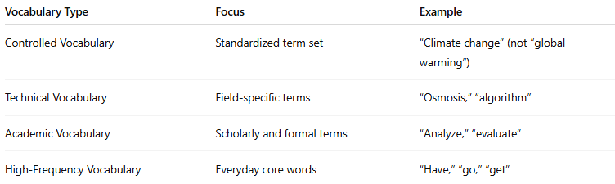
Vocabulary Type | Focus | Example
Controlled Vocabulary | Standardized term set | “Climate change” (not “global warming”)
Technical Vocabulary | Field-specific terms | “Osmosis,” “algorithm”
Academic Vocabulary | Scholarly and formal terms | “Analyze,” “evaluate”
High-Frequency Vocabulary | Everyday core words | “Have,” “go,” “get”

